**Addendum #1**

**ITB #17-20, Laboratory Services**

**2/14/20**

**NOTICE IS HEREBY GIVEN** that the following addendum serves to provide clarification and to answer the questions received on ITB # 17-20, Laboratory Services.

Replace: Exhibit A- Bid Pricing Sheet with REVISED_Exhibit A- Bid Pricing Sheet. (2/14/20)

Question 1: Under 503 Biosolids Testing the first line item Volatile Solids(biosolids) says 3,285 of these samples per year. Is that correct? Did you have that many last year? The second line item is Total Solid Sludge, Percent(biosolids) 2,555 samples per year. Is that correct? Did you have that many samples last year? All the other tests have quantities of 12.

***Answer to Question 1: Yes, the quantities listed in the Estimated Samples per Year column for 503 Biosolids Testing are correct.  The number of samples have increased significantly from the prior bid (ITB#01-17) because analysis of these samples were performed internally in years prior.  The current bid seeks to outsource this testing.***

Question 2: Which effluent toxicity tests are required? Do you just want vendor to put cost plus %?

***Answer to Question 2: The city uses Pimephales promelas and Ceriodaphnia dubia for toxicity testing. This portion may be subcontracted. Refer to Answer to Question 7 for more information regarding pricing.***

Question 3: Does the city supply a boat for ambient or can there be a line item for renting our boat(s)?

***Answer to Question 3: The City will not provide a boat for ambient collection. Vendors should consider the cost of all labor, supplies, materials, professional equipment, vehicles, tools, supervision necessary to perform the laboratory services, and sampling procedures when pricing items and charge accordingly.***

Question 4: Can we please publicly request the rest of the pricing details from last ITB or current contract? How much did City actual spend for outside testing with ITB 01-17 last year?

***Answer to Question 4: The itemized bid pricing sheets submitted by the awarded vendors of ITB #01-17 have been added to the SOLICIATION DOCUMENTS, Previous Bid Tabulation (2017) section of our website and can be found here:*** [**https://www.myclearwater.com/business/rfp**](https://www.myclearwater.com/business/rfp)**. *A cost breakdown for ITB #01-17, by fiscal year, is given in Answer to Question 5 below.***

Question 5: Can you please provide the total paid out under this contract for the past two years?

***Answer to Question 5:******Below is a list of City expenditures for laboratory services related to ITB #01-17:***

***Fiscal Year 2018: $38,816***

***Fiscal Year 2019: $61,820***

***Fiscal Year 2020: $36,292 (first 4 months of this Fiscal Year) with a projected spend of $110,000.***

***Chronic Toxicity Testing was not included in ITB #01-17 but awarded separately to EA Engineering Science and Technology Inc. This testing has since been added to the current solicitation for laboratory services. The spending for Toxicity Testing is as follows:***

***Fiscal Year 2018: $13,882.40***

***Fiscal Year 2019: $31,854.80***

Question 6: The way Organic tests are listed on the pricing sheet may not be providing the City with the most useful and accurate figures for evaluation.  For instance, in Group 3 Volatile Organic Compounds (rows 260-296), there are 36 individual line items (chemical compounds).  All of those line items are actually produced by one test (EPA 8260) and could be combined and priced as one line item.  And the City’s end user would be very unlikely to order the tests by listing out every individual compound.  If a bidder bid each compound at say $40, then the current format would calculate their total price at a quantity of 4 x 36 line items x $40 = $8,640.  When in reality, it should be a quantity of 6 x $40 = $240.  If another bidder bid $50 for the same line items, their actual bid should be $300 (6x$50), but the current format tallies it at 6 x 36 x $50 = $10,800.  For evaluation purposes, what should be a $60 difference between the two bids is now magnified into a $2,160 difference.  I cannot imagine a reputable lab billing you this way (a $40 test billed individually would be at $1,440!).  This issue occurs throughout the bid document and great skews the final bid tally.

A possible adjustment would be to modify the price sheet so there was a unit price for each group which would count toward the final price, but you could keep the individual line item pricing as well for the very rare event that you required an individual compound reported.  So for the Volatile example above, you would adjust the Excel file to have a bid price put in row 260 for Volatile Organic Compounds Group Price, with a quantity of 6.  And rows 261-296 wouldn’t add into the total bid.  Many government agencies bid it this way.

This occurs in:

Group 1 Annual Reclaimed Water and Eff. Analysis

Group 2 Annual 62-550

Group 3 items Pollutants of Concern, Total Toxic Organics, Influent Headworks, and Effluent Headworks.

***Answer to Question 6: The City concurs that Group tabs 1, 2, and 3 in Exhibit A-Bid Pricing do not account for group pricing.  The intent of “Group 4” is to account for group pricing as opposed to individual line items.***

Question 7: Tab Group 1–WRF:  Chronic wet (Ceriodaphnia dubia) and Chronic Wet (Pimephales proelas) do not have an estimated samples per year. Do we put a price in column F?

***Answer to Question 7:******The total number of Ceriodaphnia dubia samples are eight (8) (once per quarter across two sites) and the total number of Pimephales proelas samples are eight (8) (once per quarter across two sites).  This does not include any additional follow-up testing if needed.  REVISED_Exhibit A- Bid Pricing has been posted, adding the quantities above to Group 1- WRF, Lines 22 & 23.***

Question 8: Tab Group 1 – WRF:   Chronic wet (Ceriodaphnia dubia) and Chronic Wet (Pimephales proelas).   If these are needed can you please provide the permit for these?

***Answer to Question 8:******The City will provide the applicable permits to the awarded vendor(s) for Ceriodaphnia dubia and Pimephales proelas testing.***

Question 9: Tab 1 Group 1 -WRF:  Line items 112 (volatile Solids (Biosolids) and 113 (total solids sludge percent (biosolids).  Are the estimated number of samples per year really 3285 and 2555 respectfully?

***Answer to Question 9:******Refer to Answer to Question 1.***

Question 10: Tab 1 Group 1 -WRF:  Line items 112 (volatile Solids (Biosolids) and 113 (total solids sludge percent (biosolids).  Is the frequency correct at every two months?

***Answer to Question 10:******The frequency of collection of these samples is typically five days a week. REVISED_Exhibit A- Bid Pricing reflects this change.***

Question 11: Group 1 – WRF Line 73 for Chlordane (Technical mix. And metabolites) Are the metabolites require?

***Answer to Question 11: Yes, the metabolites are required.***

Question 12: Group 3 – IPP Line 134 for Chlordane (Technical mix. And metabolites) Are the metabolites require?

***Answer to Question 12: Yes, the metabolites are required.***

Question 13: Group 3 – IPP Line 154 for DOC.  Will this sample be filtered upon collection by the City of Clearwater?

***Answer to Question 13: The City will meet any requirements of the vendor’s approved analytical method.***

Question 14: Group 3 -IPP line 36 for d-Limonene:  Does this parameter require certification and if not can it be run by GC/MS semi-vol as a TIC screen by 8270?

***Answer to Question 14:******Yes, certification is required.***

Question 15: Group 4 – Price by Group Line items 25 and 26 WTP Annual WQ:  does this include the rads, chlorite, HAAs and TTHMs?

***Answer to Question 15: Yes, rads, chlorite, HAAs and TTHMs are included.***

Question 16: Group 4 – Price by Group Line items 27 and 28 SOCs:  does this include 2,3,7,8-TCDD?

***Answer to Question 16:******Yes, all are included.***

Question 17: Group 4 – Price by Group Line item 34, IU field Samples, SVOC:   does this include the 625, 608 and 2,3,7,8-TCDD or is it only meant to be just 625?

***Answer to Question 17: No, the item includes 625, 608 and 2,3,7,8-TCDD.***

Question 18: Group 4 – Price by Group Line item 34, IU field Samples, SVOC: doe the 608 require the metabolites for chlordane?

***Answer to Question 18:******Yes, this item requires the metabolites for chlordane.***

Question 19: Will the city accept Total Cyanide by 365.4 for the Group 2 tab line item 47?

***Answer to Question 19:******No, 365.4 is total Phosphorous by Automated Colorimetry and is not an appropriate test method for cyanide.***

Question 20: Please provide a detailed copy of the City’s current contract pricing for this work.

***Answer to Question 20:******Refer to Answer to Question 4.***

Question 21: What was the City’s actual spend for outside laboratory services during the 2018 and 2019 fiscal years?

***Answer to Question 21:******Refer to Answer to Question 5.***

Question 22: For the PFAS analysis requested in groups 1 and 2, please provide a list of the analytes and limits you will need reported.

***Answer to Question 22:******Limits are depended on the permits that will be provided upon award to the Vendor(s).  An anticipated analyte list is provided below (next page):***

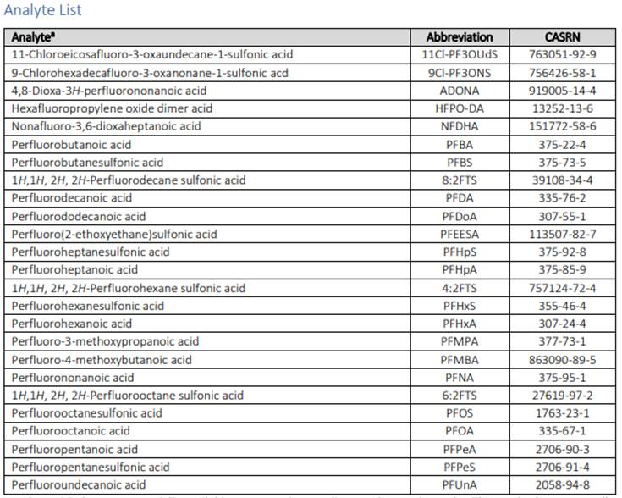

Question 23: Who is the incumbent outside laboratory?

***Answer to Question 23:******Pace Analytical Services LLC and Advanced Environmental Laboratories are the City’s current laboratory service providers.***

Question 24: Are method substitutions allowed?

***Answer to Question 24: Yes, substitutions are allowed. All methods must be approved by The NELAC Institute (TNI) and the Florida Department of Health (FDOH).***

Question 25: Please clarify your use of the term “Subcontractor” – i.e., are multiple lab locations in the same company considered “subs”?

***Answer to Question 25:******The term “subcontractor” in this bid refers to a third-party entity, not multiple locations in the same company.***

***Please Note:***The ten (10) day deadline for submitting questions is now closed and no further questions will be responded to.

*End of Questions and Answers*

All other dates and terms and conditions remain the same in this Invitation to Bid.

*End of Addenda*